**GoDaddy**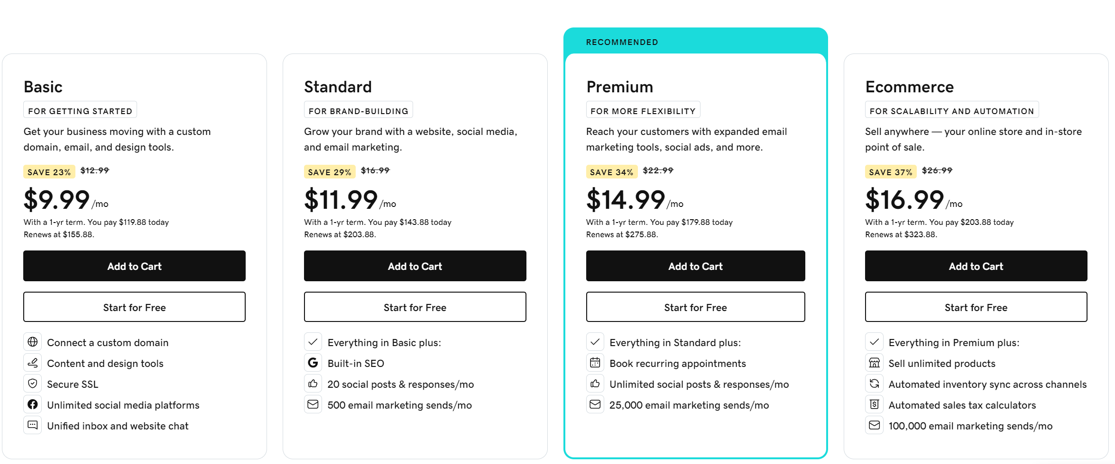

* Simple & Affordable
* Great for simple websites, with limited customizations
* Offers completely free sub domain plan with ads
* Not drag n drop

**SS**

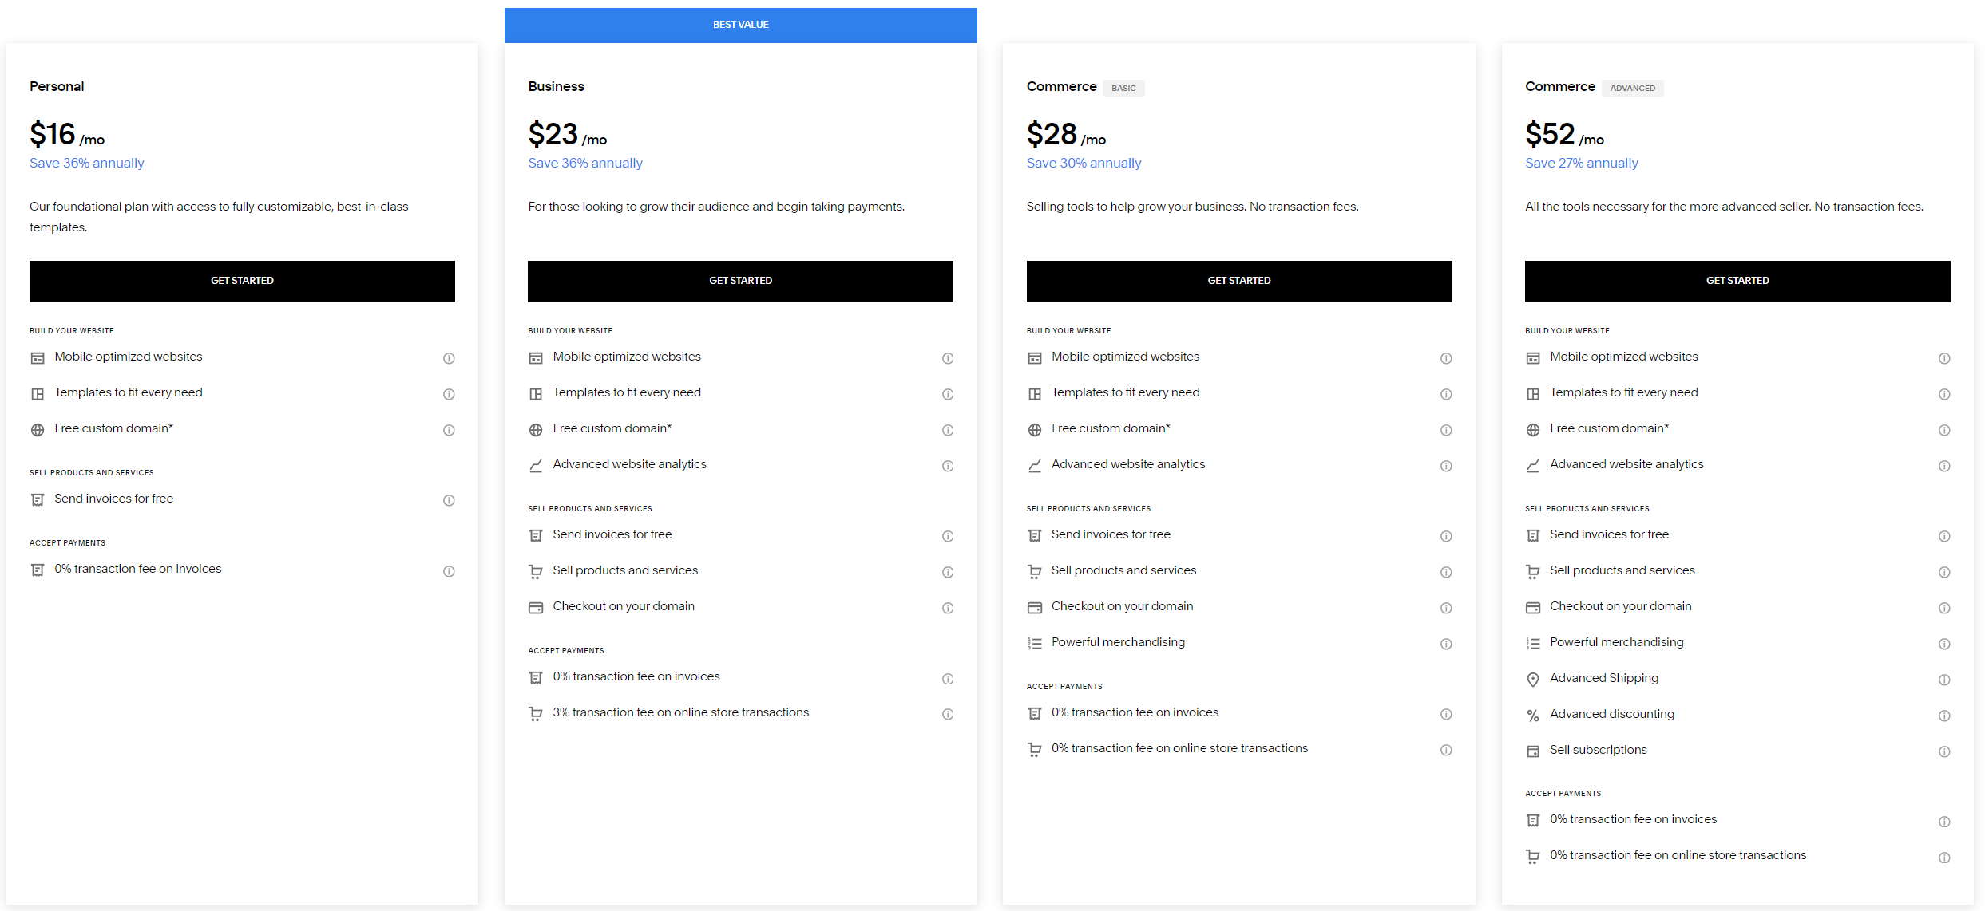

* Flexible and easy to use
* Login features
* Online Classes and appointments
* Not ideal for text-heavy sites
* Great for podcasters (not embedded)
* Good balance between flex and ease-of-use, customization without being overly complicated for beginners. Great for Blogs, great alt to WordPress. WP requires lots of plugins.
* SEO optimization options, newsletters, members only area for exclusive content
* 3% transaction fee unless bump up to Commerce plan
* Drag-n-drop, more section based
* Best for Blogs

**Wix**

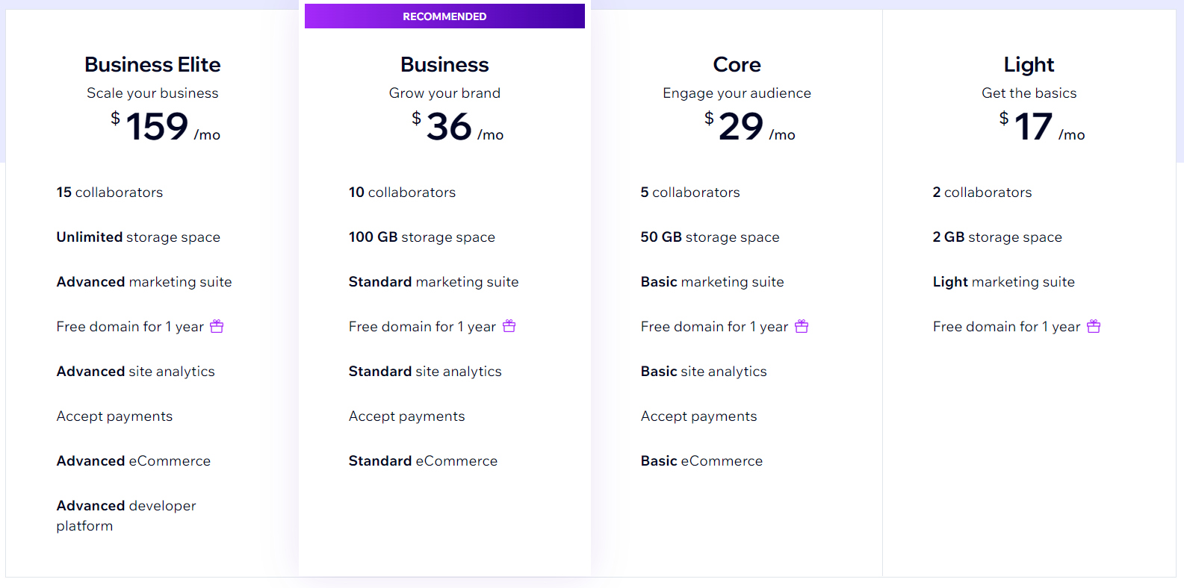

* Many templates & even more flexible
* Drag-n-drop
* Limited customization
* More flexibility than SS, easier to make mistakes because so much control
* Long time to optimize for mobile
* Open app marketplace
* Great option for small online stores or people who already have a Wix site
* Offers completely free sub domain plan with ads
* Free domain for first year if paying annually

**WebFlow**

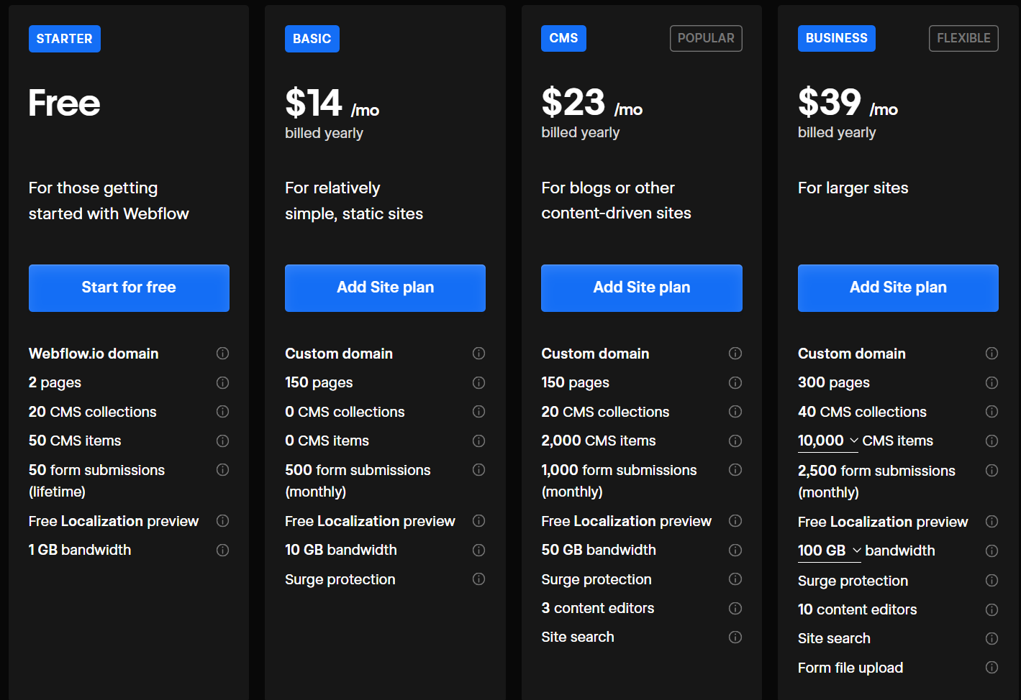

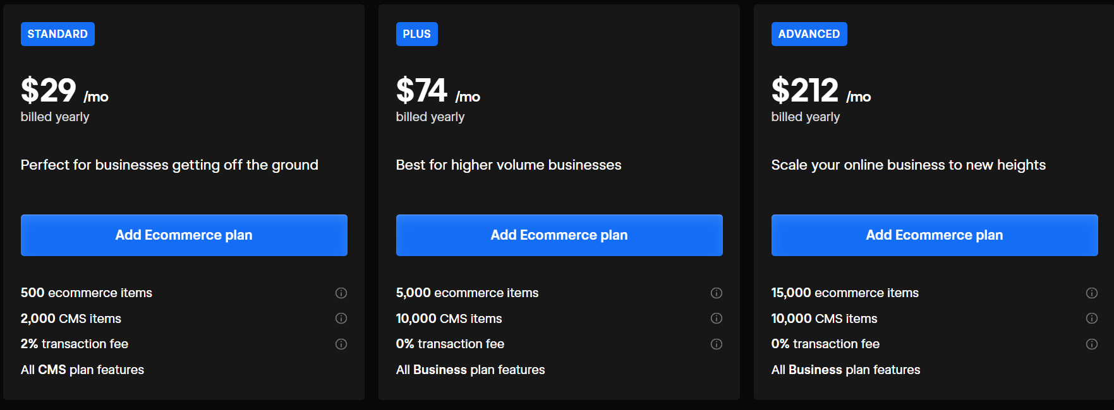

* For Designer and Devs
* Like Wix and SS, Drop n drop, more flexibility for website design
* Great for designers looking for more complex
* Advanced and more time to learn, not good for beginners
* Open market for apps and templates, over 1000 templates
* Free subdomain
* Maximum design freedom and great for completely custom

**Shopify**

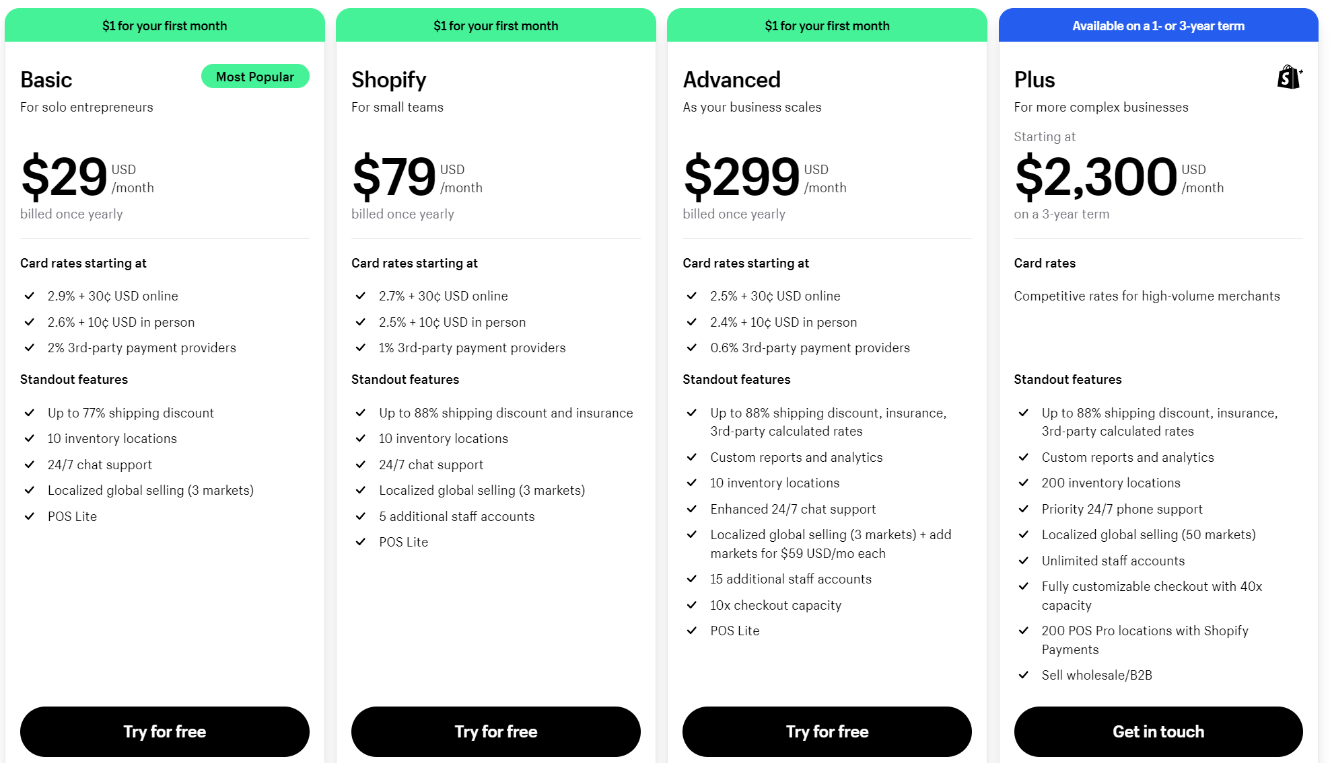

* Best for e-commerce
* No sense in non-commerce sites
* Like GoDaddy, not drag n drop
* GemPages plugin offer dnd
* Over 8000 apps
* Only 11 free templates
* Top recommendation for e-commerce for effective and quick

**WordPress**

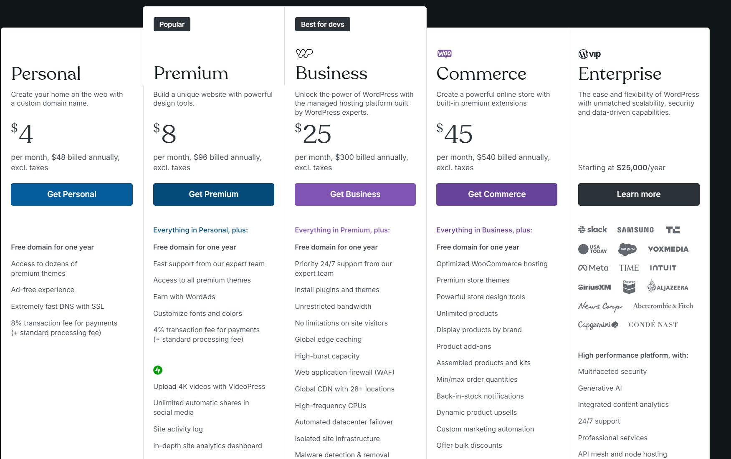

* No limits
* Most popular platform, 43%
* Best for blogs
* Not an all-in-one solution
* CMS that requires to handle things yourself
* Requires technical understanding
* Learning curve
* Complete control over every aspect of website
* Over 55,000 plugins
* Thousands of free and paid templates
* Dnd called Elementor
* Can use Hostinger to host website as low as $2/month

Table Template

